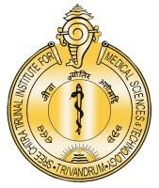

**श्री चित्रा तिरुनाल आयुर्विज्ञान और प्रौद्योगिकी संस्थान, त्रिवेंद्रम, तिरुवनन्तपुरम - 695 011, केरल, भारत**

SREE CHITRA TIRUNAL INSTITUTE FOR MEDICAL SCIENCES AND TECHNOLOGY (SCTIMST)

THIRUVANANTHAPURAM–695011, KERALA, INDIA

(An Institute of National Importance under DST; Government of India) (***एक राष्ट्रीय महत्व का संस्थान, विज्ञान एवं प्रौद्योगिकी विभाग, भारत सरकार)***

[www.sctimst.ac.in](http://www.sctimst.ac.in/)

**Press Release**

**Young Scientist Award for Dr Vinu Rajendran**

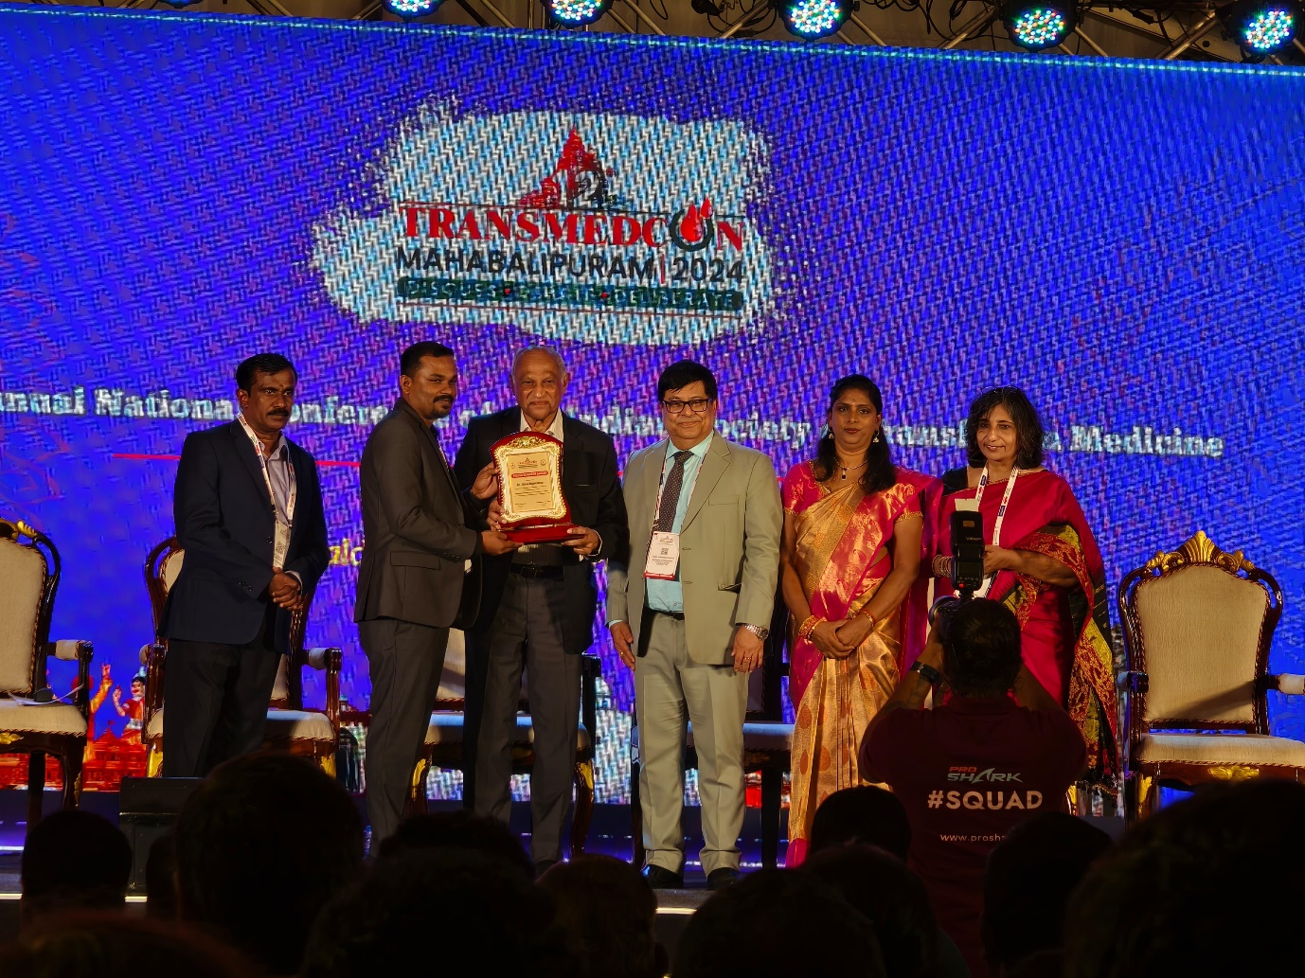

Dr Vinu Rajendran, Assistant Professor, Dept. of Transfusion Medicine, Sree Chitra Tirunal Institute for Medical Sciences and Technology has received the prestigious “Young Scientist Award” during the 12th Annual National Conference of Indian Society of Transfusion Medicine at Kaldan Samudhra Palace, Mahabalipuram. The award was given considering the innovations and research contributions in the field of Transfusion Medicine.