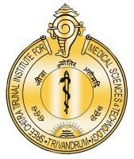

श्रीचित्रातिरुनालआयुर्विज्ञानऔरप्रौद्योगिकीसंस्थान, त्रिवेंद्रम, तिरुवनन्तपुरम - 695 011, केरल, भारत
SREE CHITRA TIRUNAL INSTITUTE FOR MEDICAL SCIENCES AND TECHNOLOGY (SCTIMST)
THIRUVANANTHAPURAM–695011, KERALA, INDIA
(An Institute of National Importance under DST; Government of India) (एकराष्ट्रीयमहत्वकासंस्थान, विज्ञानएवंप्रौद्योगिकीविभाग, भारतसरकार)
www.sctimst.ac.in
Press Note

Inauguration of New Pradhan Mantri Swasthya Suraksha Yojana (PMSSY) Building at Sree Chitra Tirunal Institute for Medical Sciences and Technology

The Sree Chitra Tirunal Institute for Medical Sciences and Technology (SCTIMST) proudly announces the inauguration of its new Pradhan Mantri Swasthya Suraksha Yojana (PMSSY) building. The state-of-the-art facility will be inaugurated by Dr. JP Nadda, the Hon’ble Cabinet Minister, Ministry of Health and Family Welfare and Ministry of Chemicals and Fertilizers and by Dr. Jitendra Singh, the Hon’ble Minister of State (Independent Charge), Ministry of Science and Technology and Ministry of Earth Sciences, Government of India, on 20.02.2025 at 10.00 am.
The ceremony will be conducted in the presence of Shri. Suresh Gopi, Hon’ble Minister of State, Ministry of Petroleum and Natural Gas and Ministry of State for Tourism; Smt. Veena George, Hon’ble Minister, Health, Woman and Child Development, Government of Kerala, Dr. Shashi Tharoor, Hon’ble Member of Parliament, Thiruvananthapuram, Kerala, Chairperson, Parliamentary Standing Committee, Dr. V.K Saraswat, Hon’ble Member NITI Aayog and Former President of the Institute, Shri. V. Muraleedharan, Former Minister, Minister for State for External Affairs & Parliamentary Affairs, Prof. Abhay Karandikar, Hon’ble Secretary, Department of Science and Technology, Government of India, Shri. Kadakampally Surendran, Hon’ble MLA, Thiruvananthapuram, and many other esteemed dignitaries.
SCTIMST is an Institute of National Importance under the Department of Science and Technology, Government of India. It is a leading tertiary care referral centre that provides world-class medical care for patients with cardiac and neurological diseases. The institute's advanced facilities, experienced medical professionals, and multidisciplinary approach ensure that patients receive the highest quality of care. SCTIMST is also renowned for its cutting-edge medical research, innovative technologies, and commitment to providing high-quality, affordable healthcare. Dr. Kris Gopalakrishnan, former Chairman, Infosys, is the President of the Institute.
The new hospital building is a key project funded under the Prime Minister's Swasthya Suraksha Yojana (PMSSY). This initiative is being supported collaboratively by the Department of Science & Technology, Government of India and the Ministry of Health & Family Welfare, Government of India.
The new PMSSY building represents a significant expansion of SCTIMST's infrastructure and its commitment to providing advanced healthcare services to the public. Spanning 9 floors and covering a built-up area of 270,000 square feet, this centrally air-conditioned building is equipped with 170 beds, including 130 beds dedicated to Intensive Care Unit (ICU) services. Additionally, 40 rooms will be allocated as pay wards to meet the increasing demand from patients. Once fully operational, this super-specialty facility will house several centres of clinical excellence, supporting 9 ultra-modern operating theatres, MRI & CT scan capabilities, 3 Cath labs, a sleep study unit, an echocardiography suite, a non-invasive cardiology evaluation suite, and other advanced neuro-cardiac care services. This hospital building will also feature modern wellness centres for patients, counselling rooms, and cafeteria.

The PMSSY building

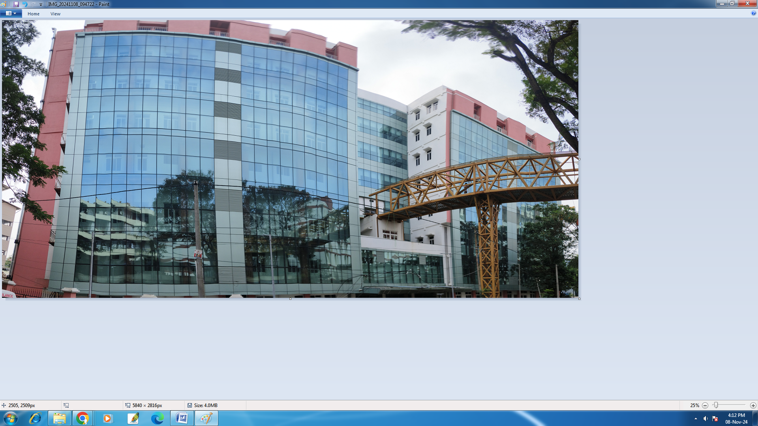

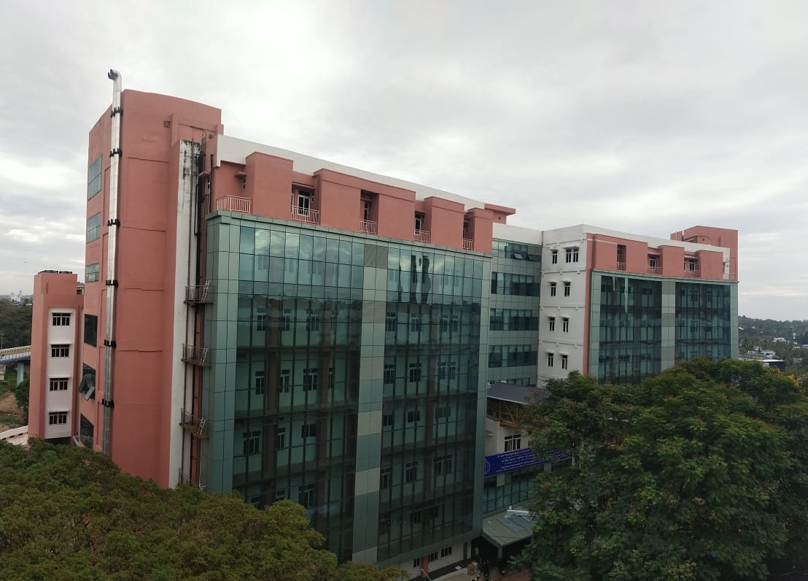

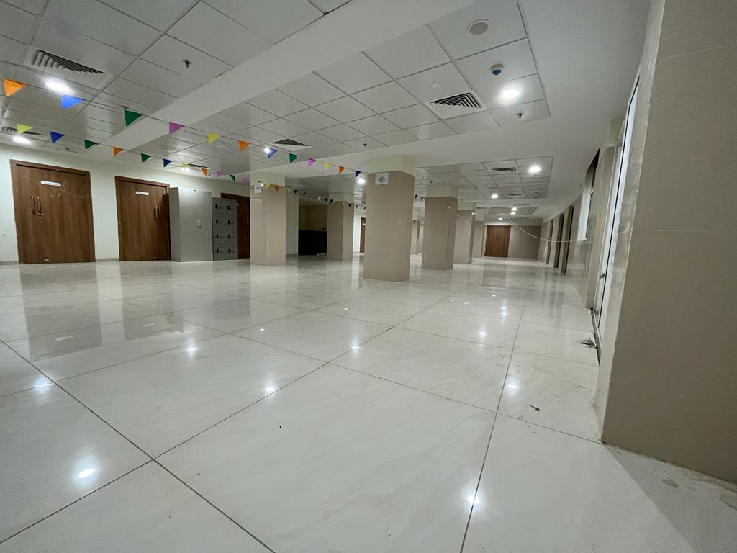
A view of the OPD Area in One Wing
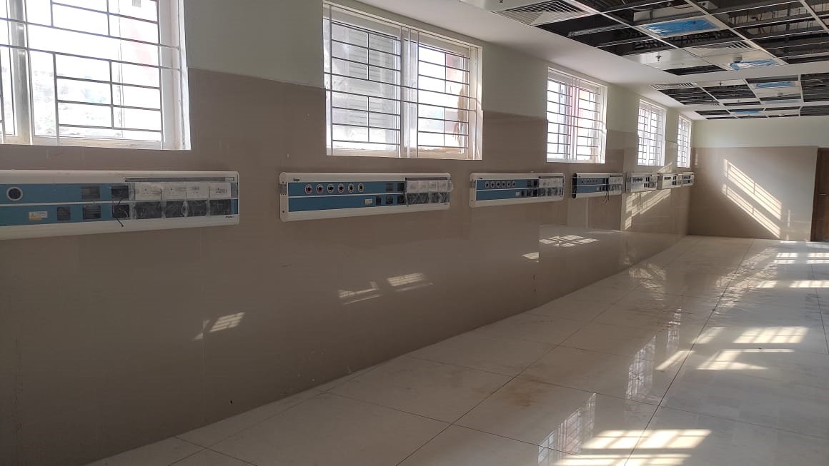
A View of an ICU

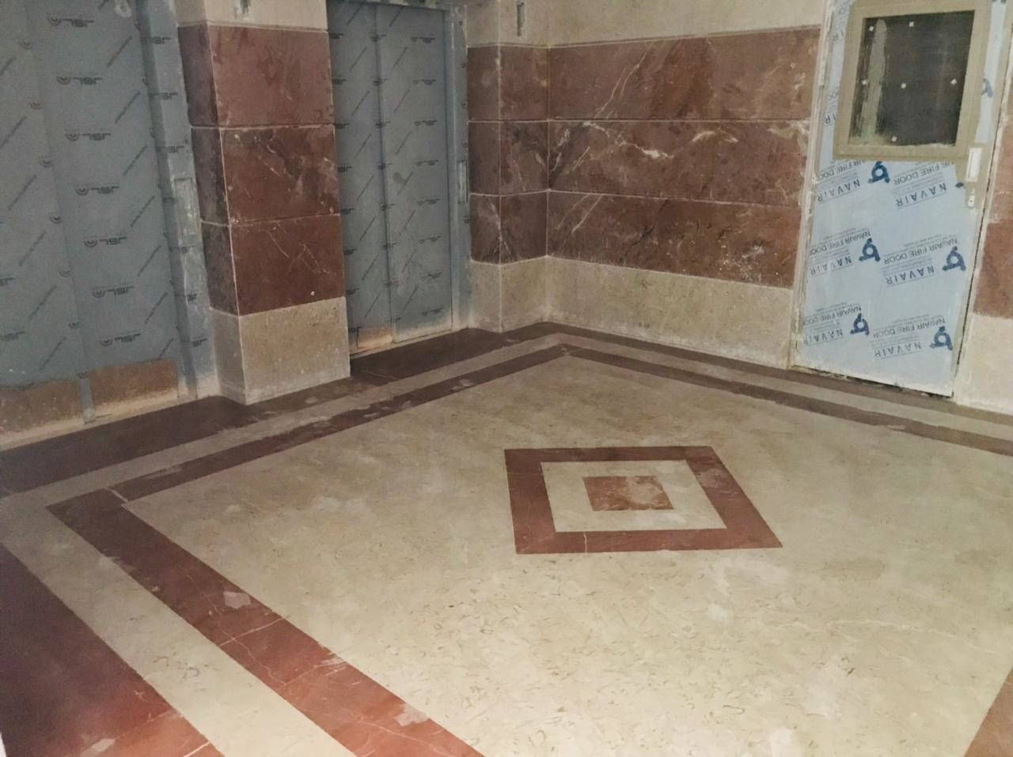
A View of Lift Lobby

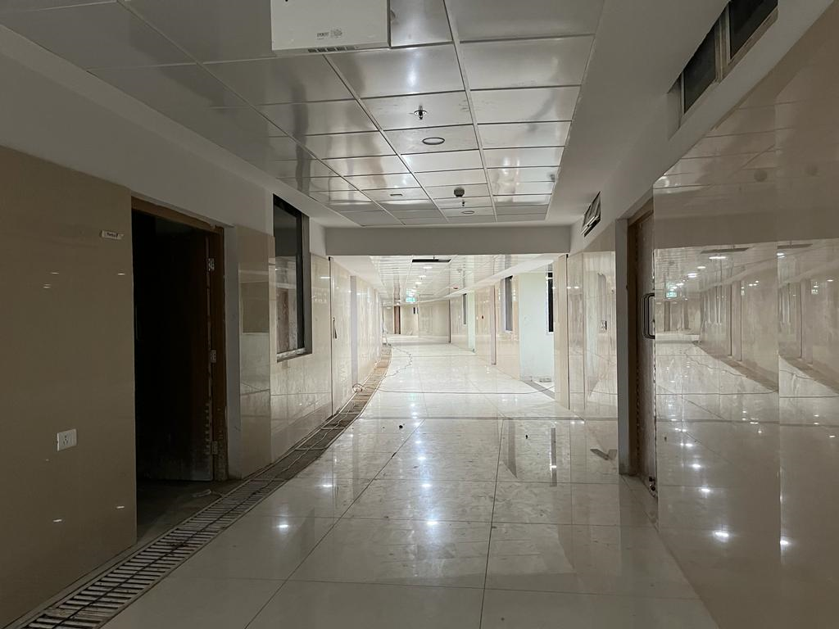
A View of Basement Floor

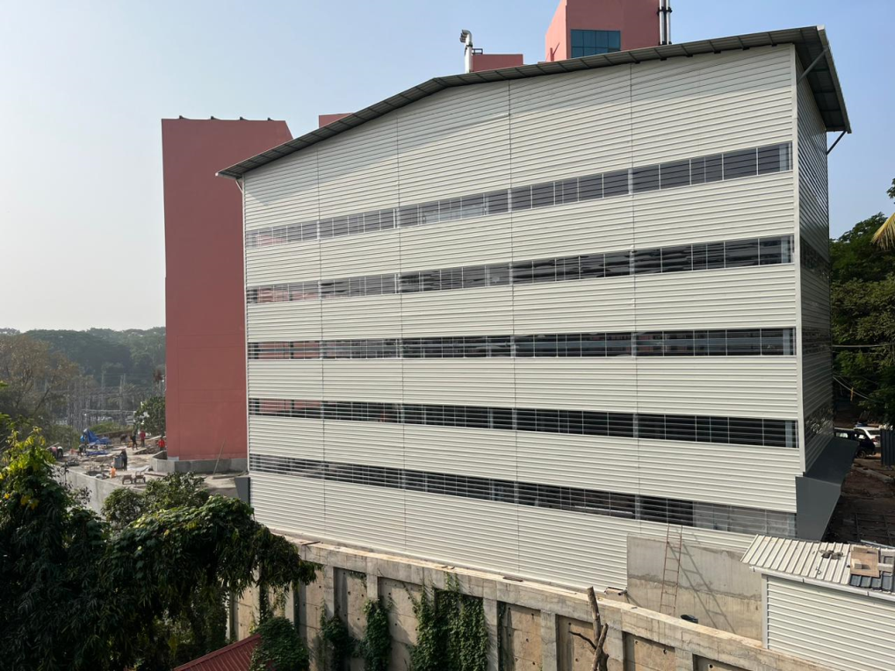

A View of Multi-level Car Parking
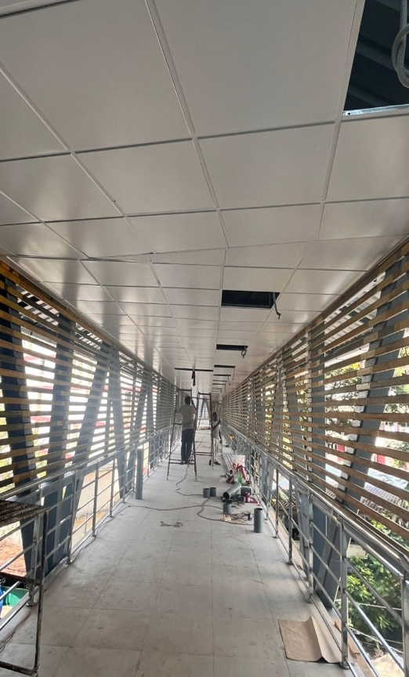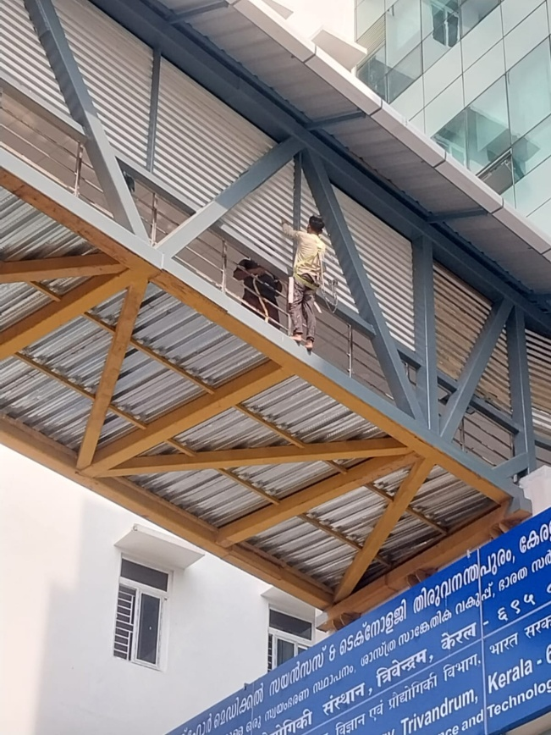
A View of the Connecting Corridor
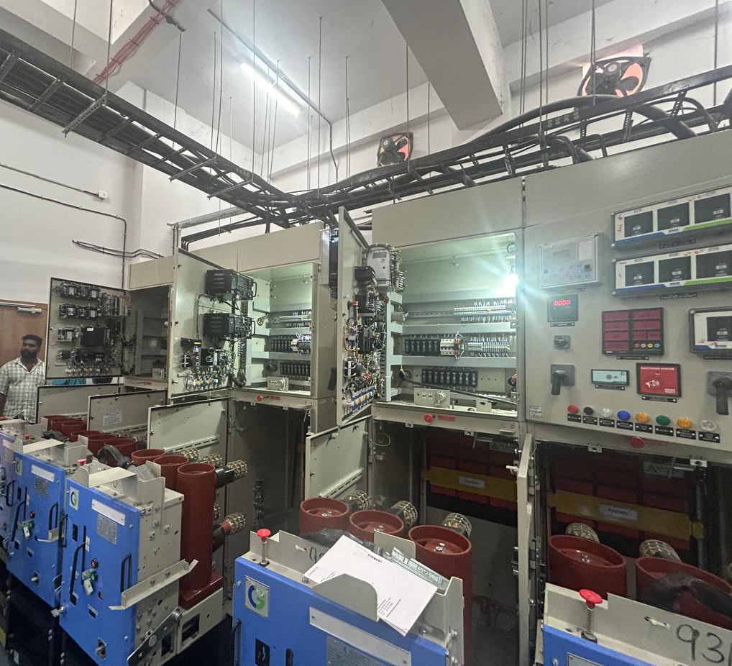
Service area light, transformers, generators.

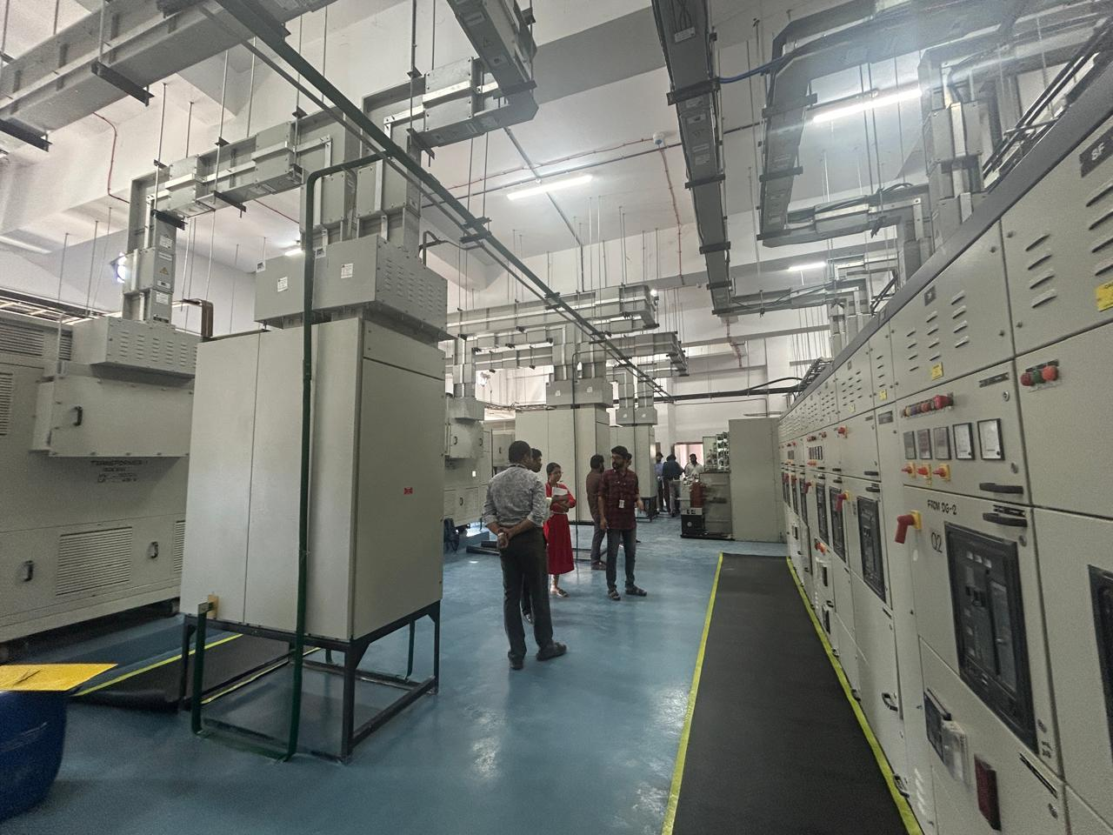
Service area light, transformers, generators.
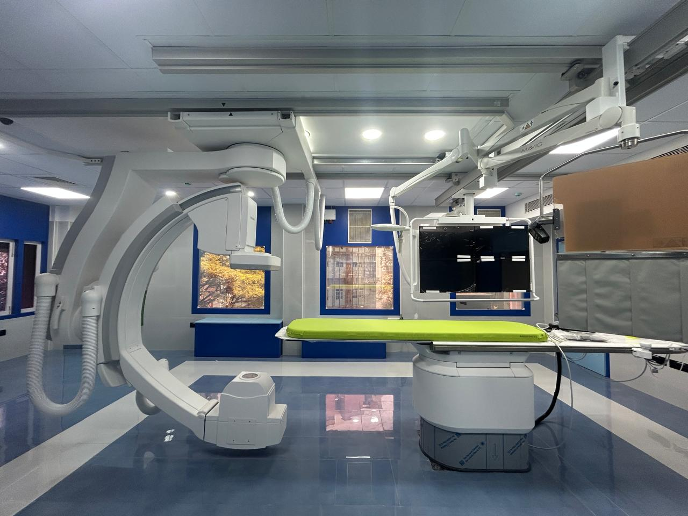
The newly established cath lab in the old building

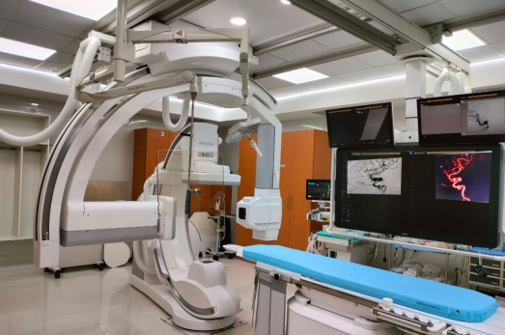
The newly established neuroradiology cath lab in the old building

